Bio 107 Lab 2
Introduction
Enzymes are protein molecules responsible for catalyzing the chemical reaction within a cells. Catalyzing is the speeding up of the chemical process that happen within a cell. Enzymes are very important aspects of life by aiding a significant number of functions in the body like, metabolism, and digestion of food (Seyis & Aksoz, 2004). Each enzyme in the body has its own specific function it serves, the high level of specialization ensure that all process have their own enzymes. Explain how enzymes catalyze chemical reactions (Montalto et al., 2006). Substrates are molecules that work hand in hand with enzymes by binding on an enzyme in a region referred to as active site. The lock and key model and the induced fit model are two models that extrapolate on the enzyme substrate interaction.
The pH levels is spread between acidic and basic concentration. The bases pH scale is between 8 and 14 while the acidic scale is between 0 and 6 (Seyis & Aksoz, 2004). The changes in pH levels affects the enzymatic activity of lactase. The enzymes are very sensitive to pH change of the surrounding environment which alters the shape of the active sites affecting the rate of enzyme substrate interaction. The resultant effect of these rate of enzyme substrate interaction causes either a reduction or increase in enzymatic reactions (Saqib et al., 2017). Lactase optimal pH is between 2.0 to 4.0 pH which is moderately acidic. These is because the pH of lactase is 6 and operates within the normal temperatures of 37 degrees Celsius.
Lactase is an important enzyme in the digestion of food, is referred to as lactase-phlorizin hydrolase, found in the small intestine responsible for breaking down lactose into glucose and galactose (Ianiro et al., 2016). The experiment is used to measure the rate of change in concentration by product of the reactions per unit time in different pH levels. The enzymes performance under different circumstances and the net effect on the product. From the absorption spectrum we determine which wavelength of light is most effective to use in spectrophotometry assay (Deng et al., 2015). The equation from a standard curve will be used to determine the concentration per unit time hence evaluate the effectiveness of lactase enzyme. The body breaks down enzymes over time hence the effectiveness of the enzyme reduces with time.
Results
According to figure 1: the rate of enzymes reaction against pH level the slope of the graph is 8.571429 Nm/min. At lower pH lactase is less reactive considering pH 1 has 1.11, pH 3 has 14.44, but at pH 7 which is our control experiment is at 103.37 Nm/min. while pH 8 has a reaction of 25.6 Nm/min.
Part A
From figure 1 on the rate of enzymes reaction against pH level the slope calculated by change in y axis divide by the change in x axis. Slope = (64-40) / (8-5.2) which is equal to 8.571429 nmol/min. From figure 2, we have the one sample t-test for hypothesised mean of the 103.37. It gives a mean of 4, standard deviation of 18, and a hypothesised mean difference of 52.24. The p value for the t-test is in the case of a one tail test is 0.14 while in the case of the two tail test the p value is 0.28.
Part B
The enzymes activity increases as the time increases from 0 minutes to 4 minutes gradually for all the pH values. The enzyme reaction decreases at the end of the 4 minutes. From the enzyme assay, lactase is mixed with phosphate buffer. There are three tables for these data sets; Figure 3, figure 4, and figure 5. Figure 3 represents the data for the first table which has a slope of 0.142 nM/min. Figure 4 represents table 2 which has a sloe of 0.068 nM/min. Figure 5 represents the data set of the last table which has a slope of 0.136 nM/min. The slopes of the three graphs represent the rate of reaction for lactase.
Discussion
Part A
Figure 1 indicates that the rate of enzymes reaction against pH level. The slope of the graph is calculated by change in y axis which is enzyme reaction rate divided by the change in x axis representing the pH values for the respective enzymatic reactions. Slope = (64-40) / (8-5.2) which is equal to 8.571429 nmol/min. The one sample t-test for hypothesised mean of the 103.37 gives a mean of 4, standard deviation of 18, and a hypothesised mean difference of 52.24. The p value for the t-test is in the case of a one tail test is 0.14 while in the case of the two tail test the p value is 0.28. The null hypothesis for the t-test states that there is a difference in the rate of enzymatic reaction at pH 1 and that of pH 7. The alternative hypothesis states that there is no difference in the rate of enzymatic reaction at pH 1 and that of pH 7. At alpha 5% that is 0.05, we accept the null Hypothesis of difference in reaction of pH levels because the p values are greater than the alpha level. Therefore, there is a significant difference in the reaction which supports the null hypothesis. Hence, it is clear that there is enough support for the null hypothesis that pH
Part B
The enzymes activity increases as the time increases from 0 minutes to 4 minutes gradually for all the pH values. The enzyme reaction has been observed to increase significantly from the initial stage up to the 4th minutes. From the enzyme assay, lactase is mixed with phosphate buffer which is the control experiment for pH 7. The other tubes of pH 5 is the actual experiment that is being categorized for the hypothesis. The hypothesis seeks to find the rate of reaction which is significant to enzymatic activities. Therefore, from the following graphs; Figure 3 represents the data for the first table which has a slope of 0.142 nM/min. Figure 4 represents table 2 which has a sloe of 0.068 nM/min. Figure 5 represents the data set of the last table which has a slope of 0.136 nM/min. The slopes of the three graphs represent the rate of reaction for lactase which are on an upward trend.
The activities of the enzymes increase as the time increases from zero to four minutes. These indicates that as the enzymes start working they increase their functionality in due time. However, for the tubes that had stayed for thirty minutes signified a very slow reaction rate which indicated that the enzymes ability to catalyze the reaction was reduced significantly. According to the research question the experiment is design to determine the effectiveness of lactase enzyme after 30 minutes of consumption. Therefore, the hypothesis that the effectiveness of lactase will be decreased after 30 minutes of consumption is true.
Lactase in the stomach pH of 4.5 to 5.5 for 30min will most likely be denatured and result in a loss in active site for ONPG. There is a significant different in the concentration of o-nitrophenol at different time intervals after the reaction of ONPG with lactase prepared at different time. However, the concentration of o-nitrophenol after the addition of ONPG in the freshly prepared lactase enzyme is the control we are comparing alongside the 30minutes Lactase consumption.
Limitations of the experiment
The amount of time the enzyme spent in the test tube with phosphate buffer was 30 minutes, which was not sufficient to have reduced lactase reaction fully. The time for recording reaction is little, the recording time should be increased. The resting time of the lactase solution should also be increased to 60 minutes. These is enough time for ensuring that most of the enzymatic reaction are greatly reduced.

Future Development
In future to help fill in the knowledge gaps associated with the lactase consumption over time, the experiment should be conducted for more than 60 minutes. The 30 minutes has very little margin in reduction of reaction rate of lactase compared to the freshly prepared lactase enzyme. The concentration of o-nitrophenol after the addition of ONPG in the freshly prepared lactase enzyme was tested and discovered to increase the rate of reaction significantly. The increment was is more pronounced than that of the 30 minutes lactase under consumption, however, the span of time for the recording is also short and ought to be increased to 10 minutes within a span of 2 minutes.

References
Deng, Y., Misselwitz, B., Dai, N., & Fox, M. (2015). Lactose intolerance in adults: biological mechanism and dietary management. Nutrients, 7(9), 8020-8035.
Ianiro, G., Pecere, S., Giorgio, V., Gasbarrini, A., & Cammarota, G. (2016). Digestive enzyme supplementation in gastrointestinal diseases. Current Drug Metabolism, 17(2), 187-193.
Montalto, M., Curigliano, V., Santoro, L., Vastola, M., Cammarota, G., Manna, R., ... & Gasbarrini, G. (2006). Management and treatment of lactose malabsorption. World journal of gastroenterology: WJG, 12(2), 187.
Saqib, S., Akram, A., Halim, S. A., & Tassaduq, R. (2017). Sources of β-galactosidase and its applications in food industry. 3 Biotech, 7(1), 79.
Seyis, I., & Aksoz, N. (2004). Production of Lactase by Trichoderma sp.

Figures
Part A
Figure 1: Reaction of Enzymes against pH Level
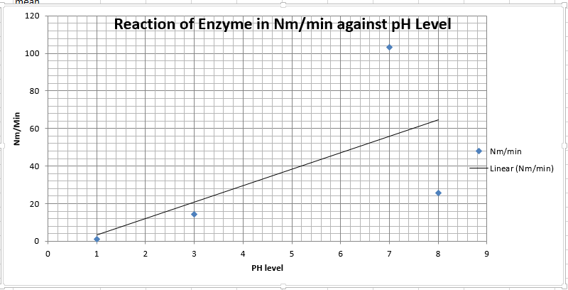
Figure 2: Paired sample t-test
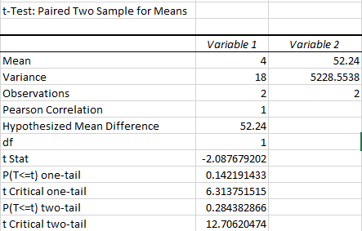
Part B
Figure 3:
Table 1:
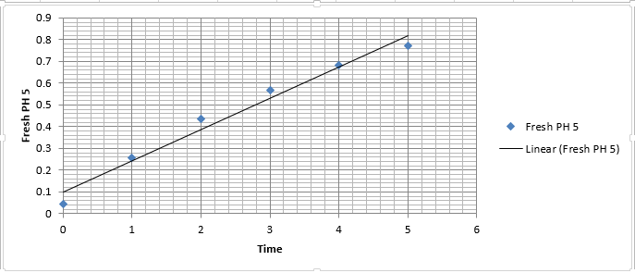
Figure 4
Table 2:
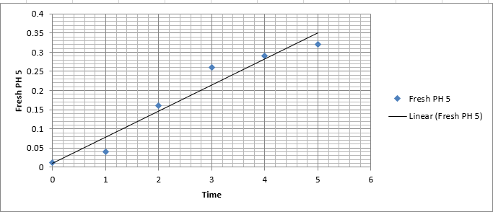

Figure 5
Table 3:
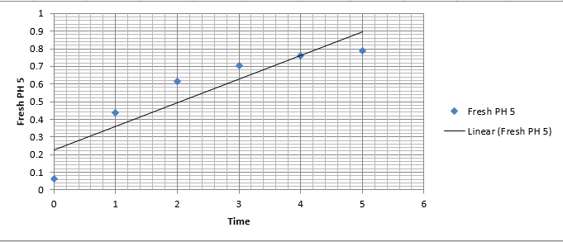

Appendix
Results: (3 group members- 3 replicates)
Table 1
Enzyme Preparation Time | 0 min | 1 min | 2 min | 3 min | 4 min | 5 min
Freshly made pH5 | 0.045 | 0.257 | 0.436 | 0.566 | 0.681 | 0.773
Old pH 5 | 0.008 | 0.076 | 0.132 | 0.183 | 0.234 | 0.284
Freshly made pH 7 | 0.007 | 0.060 | 0.108 | 0.154 | 0.196 | 0.237
Old pH 7 | 0.006 | 0.062 | 0.110 | 0.158 | 0.200 | 0.243

Table 2
Enzyme Preparation Time | 0 min | 1 min | 2 min | 3 min | 4 min | 5 min
Freshly made pH 5 | 0.011 | 0.047 | 0.160 | 0.260 | 0.290 | 0.320
Old pH 5 | 0.003 | 0.018 | 0.027 | 0.053 | 0.085 | 0.120
Freshly made pH 7 | 0.020 | 0.045 | 0.062 | 0.088 | 0.102 | 0.145
Old pH 7 | 0.003 | 0.062 | 0.089 | 0.091 | 0.140 | 0.169

Table 3
Enzyme Preparation Time | 0 min | 1 min | 2 min | 3 min | 4 min | 5 min
Freshly made pH 5 | 0.061 | 0.439 | 0.614 | 0.706 | 0.758 | 0.788
Old pH 5 | 0.019 | 0.126 | 0.219 | 0.303 | 0.360 | 0.432
Freshly made pH 7 | 0.007 | 0.065 | 0.107 | 0.156 | 0.195 | 0.244
Old pH 7 | 0.010 | 0.048 | 0.096 | 0.146 | 0.188 | 0.226

